CHAPTER 13
GRAVITATION
Discussion Questions
Q13.1 The force the earth exerts on the apple equals in magnitude the force the apple exerts on the earth. By Newton’s 2nd law equal forces produce a much smaller acceleration for the much more massive earth.
Q13.2 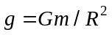. 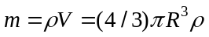 so 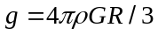. at the surface of the planet would be directly proportional to the radius of the planet.

Q13.3 The pound is a unit of force and describes the gravity force on the object. The gravity force on an object is less on Mars so it takes more butter to make a pound on Mars. The kilogram is a measure of mass, which is an intrinsic measure of the amount of material. A kilogram of butter is the same amount of butter on Mars as on the earth.

Q13.4 Because the strength of the gravity force is directly proportional to the mass of an object. More massive objects have greater gravity force on them but require a greater force for the same acceleration. In Example 13.2 the gravitational force is between the two masses. When two masses are dropped near the surface of the earth the gravitational force is between the earth and each mass.

Q13.5 At noon I am on the side of the earth facing the sun and at midnight I am on the side of the earth opposite the sun. So at noon I am closer to the sun by a distance equal to the diameter of the earth and at that point I exert a greater gravity force on the sun.

Q13.6 If there was no net force on the moon it would travel in a straight line at constant speed. A net inward force is required to keep the moon moving in uniform circular motion, and the gravity force exerted by the earth is just what is required to keep the moon moving in a circle of constant radius.

Q13.7 The orbital period for a circular orbit is given by Eq.(13.12): 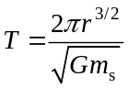, where we have replaces the mass of the earth, 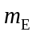, by the mass of the star, 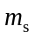. 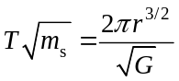, which is constant. Let be the period for a star of mass 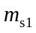 and let 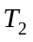 be the period for a star of mass 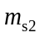. Then 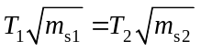. 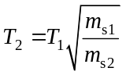. 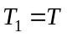 and 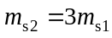. 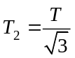. The answer is (d).

Q13.8 The orbital period for a circular orbit is given by Eq.(13.12): , where we have replaces the mass of the earth, , by the mass of the star, . T doesn’t depend on the mass of the planet, so the answer is (c) T. Applying Newton’s second law to the motion of the planet gives 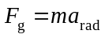. Since the gravitational force 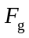 between the star and the planet is proportional to the mass m of the planet, the mass of the planet divides out of the equation.

Q13.9 The earth and moon orbit together around the sun in an orbit of nearly the same radius and orbital speed.

Q13.10 At a given distance from each, the attractive force of the earth is greater than the attractive force exerted by the moon. So, more fuel is required to go from the earth to the moon than from the moon to the earth.

Q13.11 For a circular orbit the work done is zero. We can see this in either of two ways: the force is radial and the displacement is tangential so no work is done, or, the speed is constant so the kinetic energy is constant and the work-energy theorem says the net work done on the planet is zero, For an elliptical orbit, after one complete orbit the speed has returned to its initial value, the change in kinetic energy is zero and no net work is done. For the elliptical orbit there is a component of force tangent to the path for part of the orbit and the gravity force does do work on the planet. The force does positive work during the part of the orbit where the planet is speeding up and does negative work during the part of the orbit where the planet is slowing down. But the net work for a complete orbit is zero.

Q13.12 In the analysis of Example 13.5 the escape speed is independent of the direction the projectile is launched. But, if air resistance is included the mechanical energy dissipated by work done by the air resistance depends on the path of the projectile through the earth’s atmosphere, and this path depends on the direction in which the projectile is launched.

Q13.13 To just barely escape from the earth the initial total mechanical energy of the satellite must be zero, so it can reach a point far from the earth, where the gravitational potential energy is zero, with zero kinetic energy. If the total mechanical energy is less than zero, the satellite rises to a maximum height and then falls back to the surface of the earth. It returns to the earth with the same speed with which it was projected upward. If the initial mechanical energy is greater than zero then it escapes from the earth. When it is very far from the earth it’s kinetic energy equals the total mechanical energy it had initially.

Q13.14 The statement is correct. For objects moving near the surface of the earth the elliptical path is approximated well by a parabola.
Q13.15 According to Kepler’s 2nd law, a line from the sun to the earth sweeps out equal areas in equal times. As Fig.13.19c shows, the earth moves faster when it is closer to the sun.

Q13.16 Such an orbit is not possible. The gravitational force is directed toward the center of the earth and the plane of all satellites must pass through the center of the earth. The center of the earth is one of the foci of the elliptical orbit of the satellite.

Q13.17 The acceleration is greatest when the force is greatest. This is when the satellite is closest to the object, at the perihelion. The acceleration is least when the force is least, at aphelion.
Q13.18 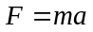 would give 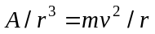, where is a constant. 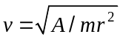 and 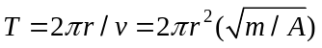. The period would be proportional to the square of the orbit radius. The requirement of elliptical orbits is only for a 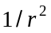 force so Kepler’s first law would no longer hold. Kepler’s second law is just a statement of conservation of angular momentum, and this holds for any central force so would be unchanged.

Q13.19 The inertia of the comet causes it to continue to move. Part of the kinetic energy it has at perihelion is converted to gravitational potential energy as the comet moves to apehelion.

Q13.20 Only at an infinite distance from the earth is its gravitational force zero. The gravity force is required to provide the radial acceleration of an orbit. If there were no gravity force on a spacecraft, the spacecraft would travel in a straight line at constant speed. An astronaut feels weightless because the spacecraft and the astronaut have the same acceleration.

Q13.21 The only force on the spacecraft and on the astronaut is gravity and they move with the same acceleration.

